ASSIGNMENT 7:

Name: Om Prasanna Kulkarni

PRN: 22510034

Batch: S3

Branch: CSE

Topic: Python Basics

Q.1) Using python command prompt try to execute below statements one by one

print(“Welcome to python programming”)

a = 50

b = 75

print(a+b)

Source Code:

print("Welcome to python programming")

a = 50

b = 75

print(a + b)

OUTPUT:



Q.2) Write a python program to assign value to a variable of following data type

also print its values along with its data type.

a) Numbers

b) List

c) Tuple

d) Byte

e) Bytearray

f) Set

g) Frozenset

h) Dictionary

Source Code:  
num_variable = 42

print("Number:", num_variable, "Type:", type(num_variable))

list_variable = [1, 2, 3, 4, 5]

print("List:", list_variable, "Type:", type(list_variable))

tuple_variable = (10, 20, 30)

print("Tuple:", tuple_variable, "Type:", type(tuple_variable))

byte_variable = b'hello'

print("Byte:", byte_variable, "Type:", type(byte_variable))

bytearray_variable = bytearray(b'world')

print("Bytearray:", bytearray_variable, "Type:", type(bytearray_variable))

set_variable = {1, 2, 3}

print("Set:", set_variable, "Type:", type(set_variable))

frozenset_variable = frozenset({4, 5, 6})

print("Frozenset:", frozenset_variable, "Type:", type(frozenset_variable))

dictionary_variable = {"name": "John", "age": 30}

print("Dictionary:", dictionary_variable, "Type:", type(dictionary_variable))

OUTPUT:

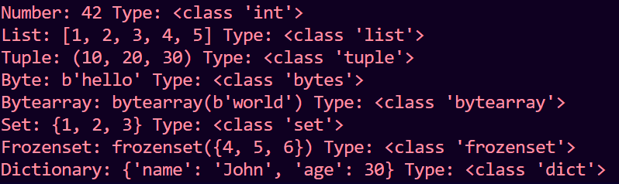

Q.3) Write a program to convert Km into meters, centimeters and millimeter

using python.

Source Code:

kilometers = float(input("Enter the distance in kilometers: "))

meters = kilometers * 1000

centimeters = kilometers * 100000

millimeters = kilometers * 1000000

print(f"{kilometers} kilometers is equal to:")

print(f"{meters} meters")

print(f"{centimeters} centimeters")

print(f"{millimeters} millimeters")

Output:

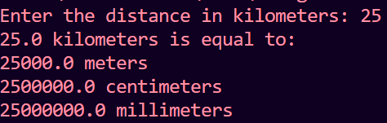

Q.4) Write a program to insert details from user (Height, weight) and display

BMI value.  
  
Source Code:

height = float(input("Enter your height (in meters): "))

weight = float(input("Enter your weight (in kilograms): "))

bmi = weight / (height ** 2)

print("Your BMI is:", bmi)

Output:

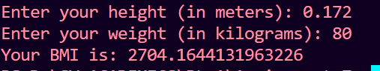

Q.5) Even or Odd Write a program that takes an integer as input and determines

whether it&#39;s even or odd.Source Code:

num = int(input("Enter an integer: "))

if num % 2 == 0:

    print(f"{num} is even.")

else:

    print(f"{num} is odd.")

Output:

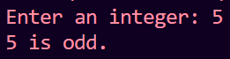

Q.6) Leap Year Checker Create a program that checks if a given year is a leap

year or not. Leap years are divisible by 4 but not by 100, except when they

are divisible by 400.

Source Code:

year = int(input("Enter a year: "))

if (year % 4 == 0 and year % 100 != 0) or (year % 400 == 0):

    print(f"{year} is a leap year.")

else:

    print(f"{year} is not a leap year.")

Output:  


Q.7)  
Factorial Calculator Write a function that calculates the factorial of a given

positive integer.

Source Code:

def factorial(n):

    if n == 0:

        return 1

    else:

        return n * factorial(n - 1)

num = int(input("Enter a positive integer: "))

if num < 0:

    print("Factorial is undefined for negative numbers.")

else:

    result = factorial(num)

    print(f"The factorial of {num} is {result}")

OUTPUT:



Q.8) Palindrome Checker Create a program that checks if a given string is a

palindrome (reads the same forwards and backwards).

Source Code:

def is_palindrome(s):

    s = s.replace(" ", "").lower()

    return s == s[::-1]

input_string = input("Enter a string: ")

if is_palindrome(input_string):

    print("The string is a palindrome.")

else:

    print("The string is not a palindrome.")

Output:  
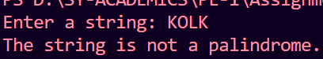

Q.9) Vowel Counter Write a function that counts the number of vowels in a

given string. Vowels are ‘a’,’e’,’I’,’o’,’u’;

Source Code:

def count_vowels(s):

    vowels = "aeiouAEIOU"

    count = 0

    for char in s:

        if char in vowels:

            count += 1

    return count

input_string = input("Enter a string: ")

vowel_count = count_vowels(input_string)

print(f"The number of vowels in the string is: {vowel_count}")

OUTPUT:



Q.10) Temperature Converter Create a program that converts temperatures

between Celsius and Fahrenheit. Provide options for the user to choose the

conversion direction.

Source Code:

def celsius_to_fahrenheit(celsius):

    return (celsius * 9/5) + 32

def fahrenheit_to_celsius(fahrenheit):

    return (fahrenheit - 32) * 5/9

while True:

    print("Temperature Converter Menu:")

    print("1. Celsius to Fahrenheit")

    print("2. Fahrenheit to Celsius")

    print("3. Quit")

    choice = input("Enter your choice (1/2/3): ")

    if choice == '1':

        celsius = float(input("Enter temperature in Celsius: "))

        result = celsius_to_fahrenheit(celsius)

        print(f"{celsius}°C is equal to {result}°F")

    elif choice == '2':

        fahrenheit = float(input("Enter temperature in Fahrenheit: "))

        result = fahrenheit_to_celsius(fahrenheit)

        print(f"{fahrenheit}°F is equal to {result}°C")

    elif choice == '3':

        break

    else:

        print("Invalid choice. Please select 1, 2, or 3.")

OUTPUT:  
